Curriculum Vitae
Nguyen L am Lam  Ho Chi Minh City, V ietnam  + 84 796373536  Lamnguyen.070602@gmail.com  LinkedIn: linkedin.com/in/lamlam-nguyen-398901251 | 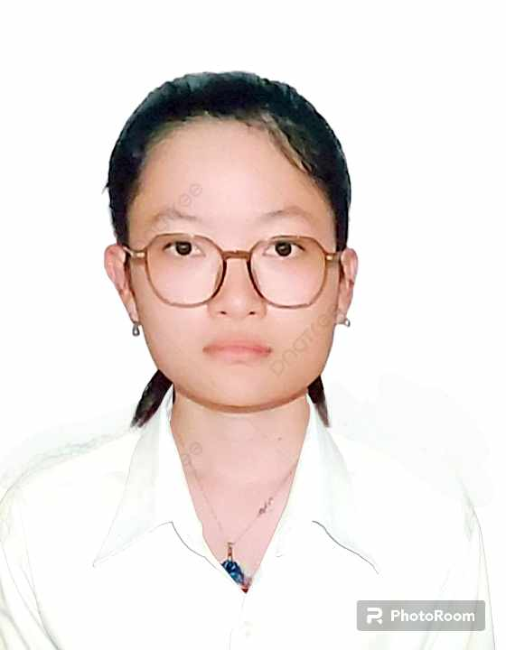

Personal Information
• Date of Birth: June 7 , 2 0 0 2
• Nationality: Vietnamese

Education
Ho Chi Minh International University
Bachelor of Science in Food Technology Graduated: 2 0 2 5
Relevant Coursework: Food Chemistry, Food Microbiology, Food Quality Management, Product Development.

Experience
Fresher ‒ Participated in laboratory practices, research projects, and product development simulations. Collaborated in group assignments on product testing, sensory evaluation, and quality assurance.
Intership and work as quality control staff at Lotus Food Group JSC.
Skills
• L anguages: English (fluent), V ietnamese (native)
• Professional: Public speaking, presentation, problem-solving
• Technical: Food sensory analysis, Food analysis, quality control, R&D; methods, lab testing
Certificates
IELTS band 6.0
Top 10 of Star up demo day 2023

Career Objective
Motivated and detail-oriented Food Technology graduate seeking an entry-level position in Research & Development, Product Innovation, or Quality Control. Dedicated to applying academic knowledge, analytical thinking, and teamwork to contribute to organiz ational growth and ensure product excellence.
Possesses strong product sensory ability.
Extracurricular Activities
• Member of University Science Club (participated in research discussions and workshops).
• Volunteered in community food safety awareness campaigns.
• Participate Food Inovation APAC 2022 and Star up demo day 2023 ( play marketing and product creation role ).

